A

PROJECT REPORT ON

**BEAUTY SALON WEBSITE**

SUBMITTED BY

**Ms. SONAM RAMKRIT VISHWAKARMA**

SUBMITTED to

**Savitribai Phule Pune University,pune**

in partial fulfillment of degree

**master of Computer Application (sem-i)**

under the guidance of

**prof. samiksha yeola**

through ,



**Sadhu Vaswani Institute of Management Studies For Girls,**

**Koregaon Park, Pune-411001**

**2024-25**



Mini Project Progress Report

**Class: MCA – I Semester – I (Academic Year 2024-25)**

**Student Name :**

**Project Table :**

**Project Guide:(Institute)**

|  |  |  |  |  |  |
| --- | --- | --- | --- | --- | --- |
| **Sr.**  **No.** | **Activity to be completed** | **Date of Completion** | | **Suggestions if any** | **Guide Sign** |
| **Expected** | **Actual** |
| 1. | **Preliminary discussion & project title finalization** | 15/07/2024 |  |  |  |
| 2. | **Synopsis submission & presentation** | 31/07/2024 |  |  |  |
| 3. | **CHAPTER 1: INTRODUCTION**   * 1. Client/Organization Profile   2. Need for System   3. Scope & Feasibility of Work   4. Operating Environment – H/w & S/w   5. Architecture of system   6. Detail Description of Technology Used | 19/08/2024 |  |  |  |
| 4. | **CHAPTER 2 : PROPOSED SYSTEM**   * 1. Proposed System   2. Objectives of System   3. User Requirements | 6/09/2024 |  |  |  |
| 5. | **CHAPTER 3 : ANALYSIS & DESIGN**   * 1. DFD   2. Table specifications (Database)   3. ERD | 23/09/2024 |  |  |  |
| 6. | * 1. Object Diagram   2. Class Diagram   3. Use Case Diagrams   4. Web Site Map Diagram (if Website ) | 10/10/2024 |  |  |  |
| 7. | **CHAPTER 4: USER MANUAL**   * 1. User Interface Design (Screens etc.)   2. Limitations   3. Future enhancement   **BIBLIOGRAPHY**  **ANNEXURE:** Sample program code | 01/10/2024 |  |  |  |
| 8. | **Review / Presentation** | 10/10/2024 |  |  |  |
| 9. | **Project soft copy checkup** | 15/10/2024 |  |  |  |
| 10. | **Final Submission** | 18/10/2024 |  |  |  |

**Note :** i) Every student should report to their assigned project guide on given date of each phase as state above & take signature of project guide on this progress report card.

ii) Every time student shall bring this report card and at the time of final project submission submit this card to the project guide.

Project Coordinator

HOD(MCA)

**DECLARATION BY STUDENTS**

To,

The Director,

SVIMS, Koregaon Park, Pune

I, undersigned hereby declare that this project titled, " **BEAUTY SALON WEBSITE** " written and submitted by me to SPPU, Pune, in partial fulfillment of the requirement of the award of the degree of **MASTER OF COMPUTER APPLICATION (MCA-I)** under the guidance of **PROF. samiksha yeola**, is my original work.

I further declare that to the best of my knowledge and belief, this project has not been submitted to this or any other University or Institution for the award of any Degree.

**Place: Pune**

**Date**

**( Sonam ramkrit vishwakarma)**

**ACKNOWLEDGEMENT**

I extend my sincere gratitude to **DR.B.H. NANWANI and DR.Neeta lokhande-raskar** for allowing me to carry out the study and for their constant encouragement, valuable suggestions and guidance during the research work.

I extend my special thanks to **Ms. samiksha yeola** **and DR.SHVETI CHANDAN** for their kind co-operation and inspiration.

I extend my special gratitude to my dearest family members and friends who encouraged and

motivated me to complete the project report.

**Place: Pune**

**Date:**

**( Sonam ramkrit vishwakarma)**

**Index**

|  |  |  |
| --- | --- | --- |
| **CHAPTER** | **DETAILS** | **Page No.** |
| 1 | **Chapter 1: Introduction**   * 1. Client/Organization Profile   2. Need for System   3. Scope & Feasibility of Work   4. Operating Environment-H/w & S/w   5. Architecture of system   6. Detail Description of Technology Used | 1-7 |
| 2 | **Chapter 2 : PROPOSED SYSTEM**  2.1 Proposed System  2.2 Objectives of System  2.3 User Requirements | 8-9 |
| 3 | **Chapter 3 : ANALYSIS & DESIGN**  3.1 DFD  3.2 Table specifications (Database)  3.3 ERD  3.4 Object Diagram  3.5 Class Diagram  3.6 Use Case Diagrams  3.7 Web Site Map Diagram (if Website) | 10-15 |
| 4 | **Chapter 4 :USER MANUAL**  4.1 User Interface Design (Screens etc.)  4.2 Limitations   * 1. Future enhancement   **BIBLIOGRAPHY**  ANNEXURE: SAMPLE PROGRAM CODE | 16-24 |

**CHAPTER 1 : introduction**

* 1. **Client/Organization Profile :**

This profile showcases the salon's commitment to excellence, innovation, and customer

satisfaction. It highlights their expertise, eco-friendly practices, and luxurious ambiance. The

profile also outlines their expansion plans, interest in collaborating with influencers and beauty

brands, and educational initiatives. Our team of expert barbers and stylists are dedicated to

delivering exceptional service, tailored to your individual needs and preferences.

Overall, this profile effectively represents the beauty salon identity, values, and services,

making it an excellent of a client/organization profile. Our mission is to empower individuals to

embrace their natural beauty through exceptional, innovative, and personalized services. Our

team of expert stylists are dedicated to providing top-quality haircut or shave services in a

tranquil and luxurious environment. From haircuts and styling to shaving and beard care, our

services are designed to help men look and feel their best. We also offer a range of skincare and

massage treatments to help men relax and rejuvenate. At Grooming Garage, we're committed to

creating a space where men can feel comfortable and at ease. Our salon is designed to be a

welcoming and inclusive environment, with a focus on providing exceptional service and

building long-lasting relationships with our clients.

* 1. **Needs for system :**

1. Appointment Scheduling:

- Ability to book appointments online or in-person

- Automated reminders for upcoming appointments

- Calendar management for multiple stylists and services

1. Client Management:

- Client profiles with contact information and service history

- Ability to track client preferences and loyalty program points

- Communication tools for email and SMS marketing

1. Service Management:

- List of services offered with descriptions and pricing

- Ability to manage service availability and scheduling

- Tracking of service popularity and revenue

1. Inventory Management:

- Management of product inventory and supplies

- Automatic tracking of product usage and reordering

- Reporting on product sales and revenue

1. Point of Sale (POS):

- Secure payment processing for services and products

- Ability to manage tips and gratuities

- Reporting on sales and revenue

a beauty salon system can help streamline operations, improve customer satisfaction, and drive business growth.

1.3 **Scope & Feasibility of work :**

Scope Work:

- Provide high-quality grooming services for men, including haircuts, shaving, beard styling, and spa treatments

- Create a welcoming and masculine atmosphere

- Offer personalized services tailored to each client's needs and preferences

- Utilize high-end products and equipment

- Maintain a clean and hygienic environment

- Build a loyal client base through excellent customer service and retention strategies

Feasibility Work:

- Market demand: Growing demand for men's grooming services

- Competition: Moderate competition, but potential for differentiation through high-end services and atmosphere

- Target audience: Men aged 25-50, middle to upper-income, living in urban areas

- Marketing strategies: Social media, online booking, referrals, partnerships with local businesses

- Operations: Hire experienced staff, train regularly, maintain high-quality products and equipment

- Financial projections: Revenue growth, increasing client base, potential for expansion

1.4 **Operational Environment -H/w & S/w**

* Client-Side System Specification :
* Hardware :

|  |  |  |
| --- | --- | --- |
| Item Name | Specification | |
| **Laptop/Desktop** | | Minimum Intel IV or above  Minimum RAM : 512 MB or more  Minimum Hard Disk : 1GB free space |

* software :

|  |  |
| --- | --- |
| Particular | Specification |
| **Operating** | Minimum windows 10 or above |
| **browser** | Google Chrome or Microsoft Edge |

* Server-side system specification :

|  |  |
| --- | --- |
| **Server** | Xampp 8.1.12 |
| **Database** | MYSQL 8.0.35 |
| **Browsers** | Google Chrome & Microsoft Edge |

* Developer-side system specification :
* Hardware :

|  |  |
| --- | --- |
| Item Name | Specification |
| **Laptop/Desktop** | Intel CORE i3, 5th GEN  RAM : 8GB  Hard Disk : 512 GB |

* Software :

|  |  |
| --- | --- |
| Particular | Specification |
| **Operating System** | Windows 10, Intel core i3 |
| **Documentation** | Microsoft Word 2010 or Higher |
| **Browsers** | Google Chrome or Microsoft Edge |
| **Editor(s)** | Eclipse 2022-12 |
| **Server** | Xampp 8.1.12 |
| **Database** | MYSQL 8.0.35 |

* Font End :

|  |
| --- |
| html |
| CSS |
| JAVASCRIPT |

**1.5** **ARCHITECTURE OF SYSTEM**

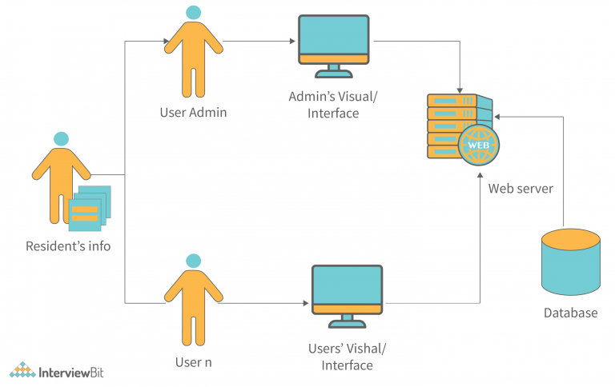

Form Submission

Contact Form

**beautician**

**Customers**

**1.6 Detail Description of technology used**

### ****1. Frontend Development****

The frontend is the client-facing part of the website, where users interact directly.

**Technologies used:**

* **HTML**: For structuring the content and layout of web pages.
* **CSS**: For styling, including colors, fonts, animations, and responsive design.
* **JavaScript**: For interactivity, such as dropdown menus, booking forms, and dynamic content loading.
* **Frameworks/Libraries**:
  + **Bootstrap** : To implement a mobile-first responsive design easily.

### ****2. Backend Development****

The backend handles the server-side operations, including database interactions, user authentication, and processing bookings.

**Technologies used:**

* **Languages**:
  + **PHP** (e.g., with Laravel) for traditional server-side logic.

### ****3. Database****

Databases are used to store information like customer details, appointments, staff schedules, and feedback.

**Technologies used: MySQL Databases**:

**chapter : 2 Proposed System**

2.1 Proposed system :

Objective is to overcome the major limitation of the existing enabling effective management of the customer details thereby improving the performance.

With improved computerization being involved in the maintenance of customer details, error and inconsistencies can be kept at par.

Easy retrieval of data will be made possible by finding techniques.

Validation of data will ensure only accurate, valid and complete data is stored in the database.

Proper monitoring of the processes from customer registration to activation. Report generation will help make it easy to analyze the performance at the Bank.

This will be much less time-consuming comparing to existing system.

2.2 Objectives of System :

1. To provide a user-friendly online booking and scheduling system for clients.

2. To manage client information and service history in a secure and organized manner.

3. To streamline the appointment scheduling process and reduce no-shows.

4. To increase sales and revenue through upselling and cross-selling of services and products.

5. To manage inventory and supplies efficiently and reduce waste.

6. To provide a seamless and integrated payment processing experience for clients.

7. To track and analyze sales, revenue, and customer behavior to inform business decisions.

8. To improve staff management and performance evaluation through scheduling and time-tracking features.

9. To enhance client communication and retention through automated reminders and notifications.

10. To increase customer satisfaction and loyalty through personalized services and packages.

2.3 User Requirements :

* Easy online booking and scheduling
* Ability to view services and pricing
* Secure payment processing
* Personalized service recommendation
* Ability to manage personal profile and service history
* Automated reminders and notifications
* User-friendly interface and navigation
* Ability to leave reviews and ratings
* Special offers and promotions
* Loyalty program integration

**CHAPTER : 3 NALYSIS & DESIGN**

**3.1 Table Specifications (Database) :**

* Contact Form

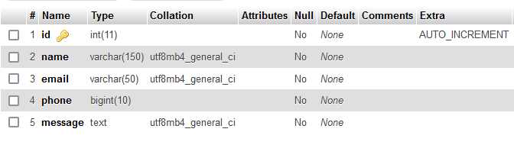

**3.2 Class Diagram :**

**Customer**

+custname: string

-custemail : string

-custphone no:string

+custmessage : string

+Custdetails()

+Searchservice()

1

1

1..*

1

1..*

1

**Notification**

-notificationId: int

+createdOn:date

+conent:strring

+send()

**Service**

+nameofservice: string

+check_availability()

+Select_sarvice()

**Manager**

+Name:string

-age :int

-sex:string

-phone:string

-address:string

-managerdetails()

+receive_message()

* 1. **Use Case Diagram :**

Customer manager

**3.5 Data Flow Diagram (DFD)**

0 Level Diagram :

Administrator

User

1 LevelDiagram :

Administrator

Administrator

**2 Level Diagram :**

**Administrator**

**tbl Contact**

**User**

Sign in

Request

Approve/Reject

Add

Add Services

**Tbl Customers**

Assign

**tbl Services**

**3.6 Entity Relationship Diagrams (ERD) :**

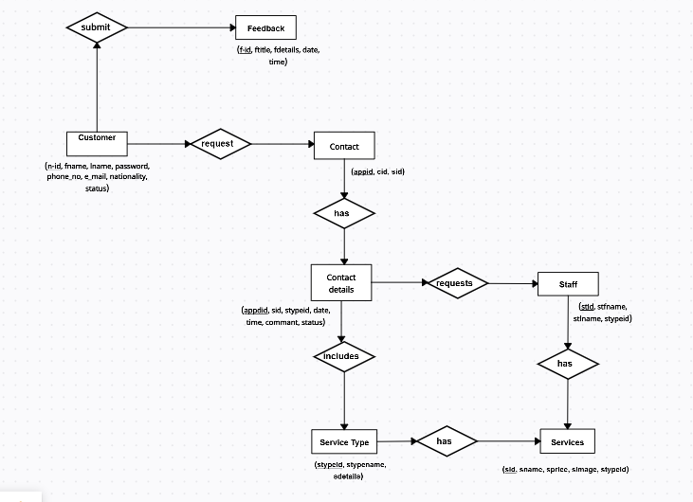

**CHAPTER : 4 USER MANUAL**

4.1 User Interface Design (Screens) :

* Home Page :

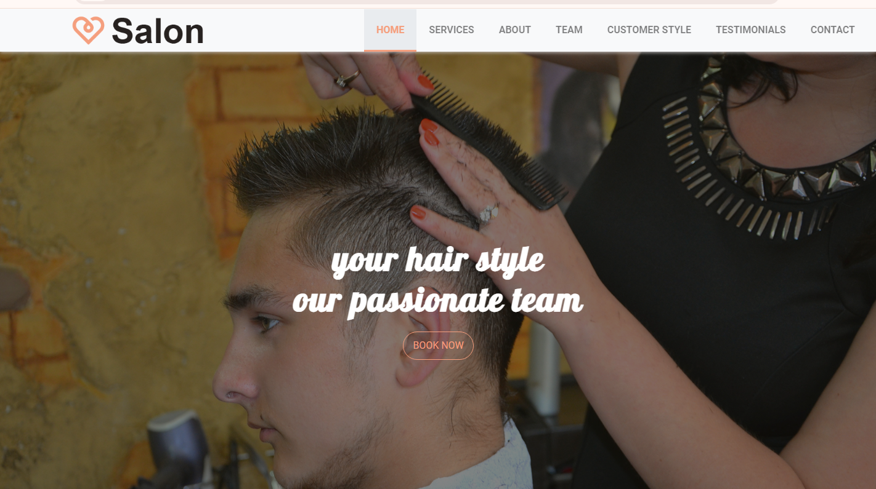

* Services :

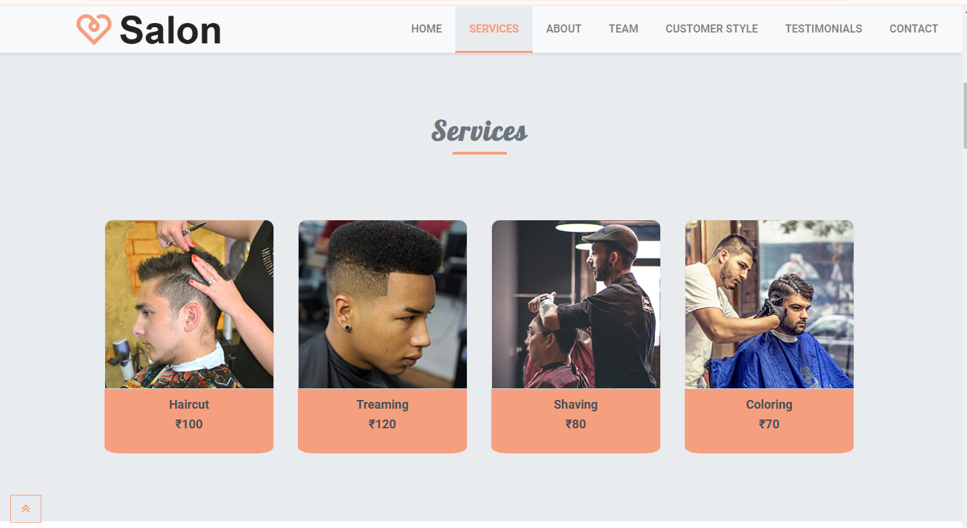

* About :

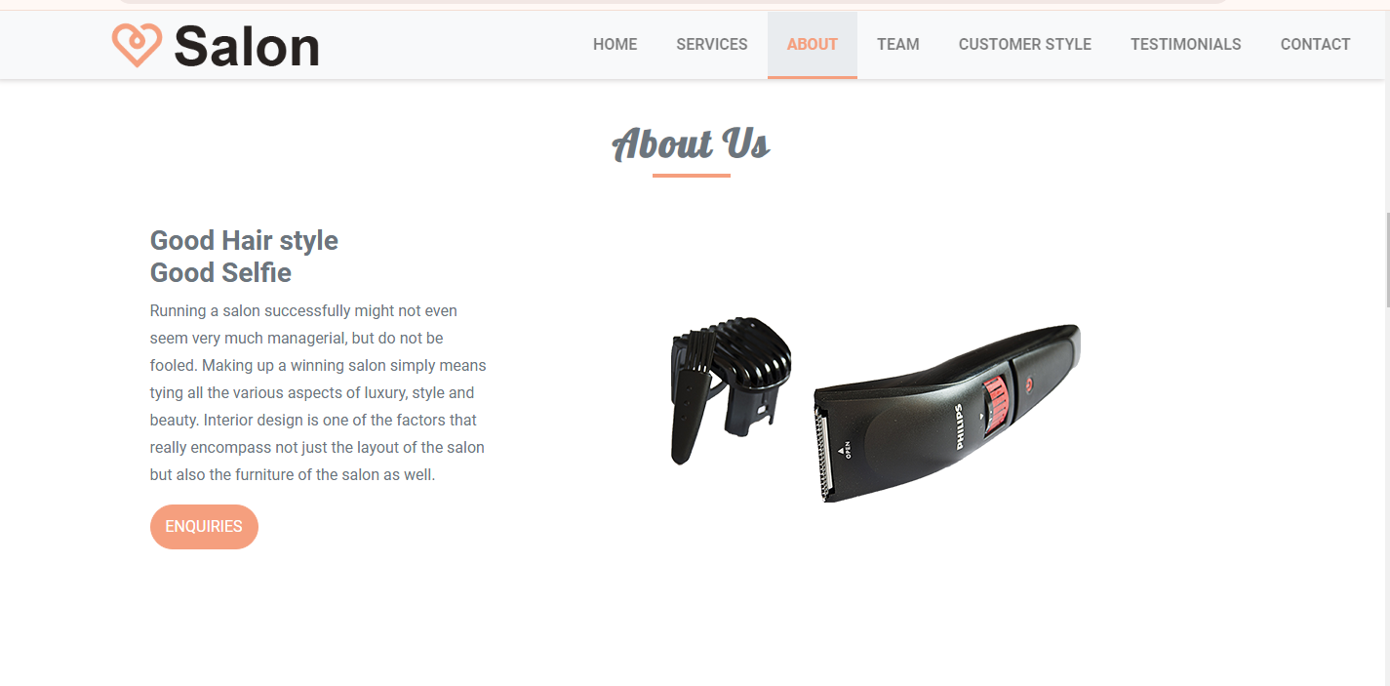

* Teams :

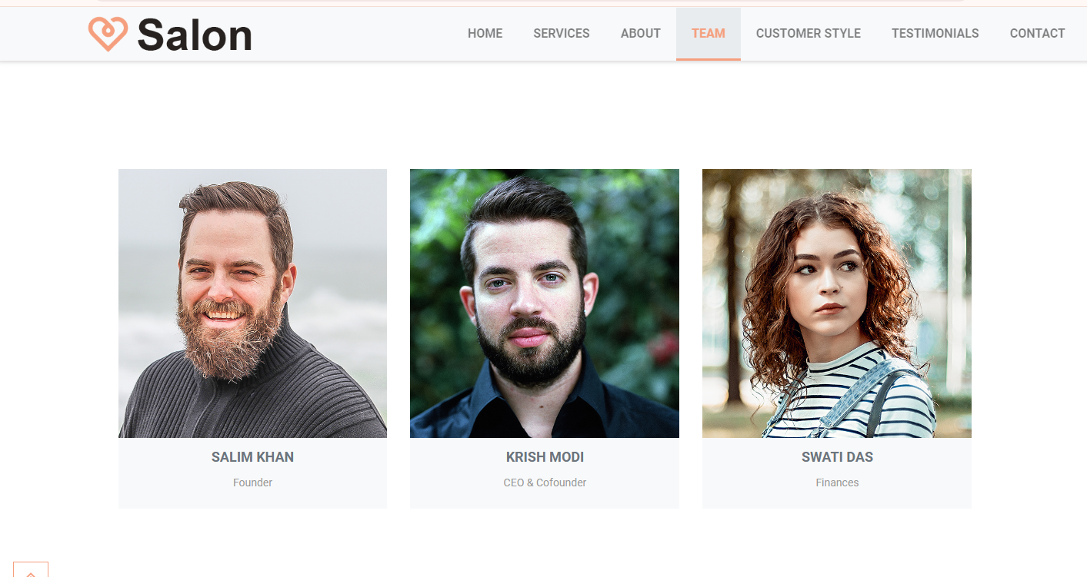

* Customer Style :

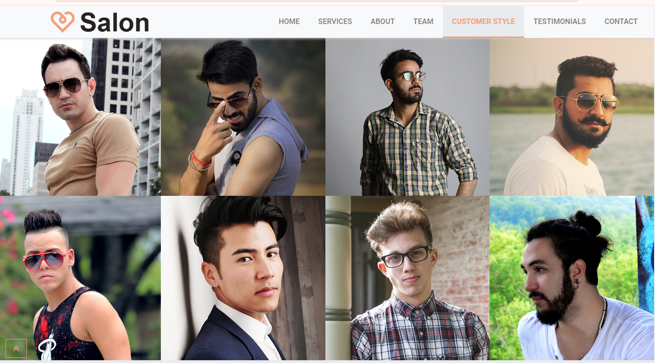

* Testimonials :

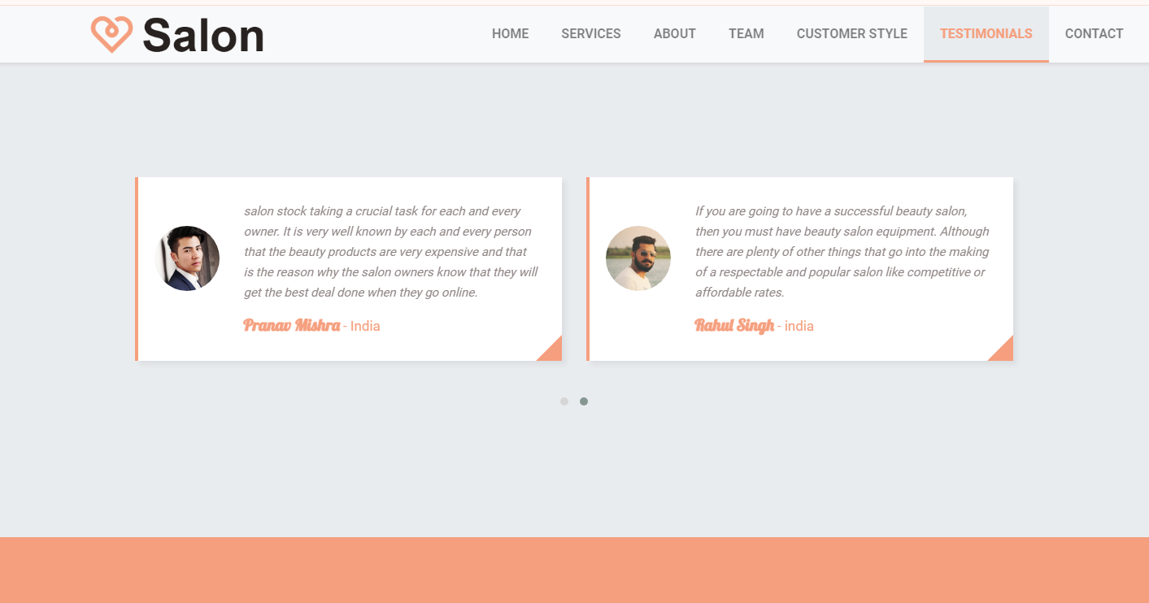

* Contact Form :

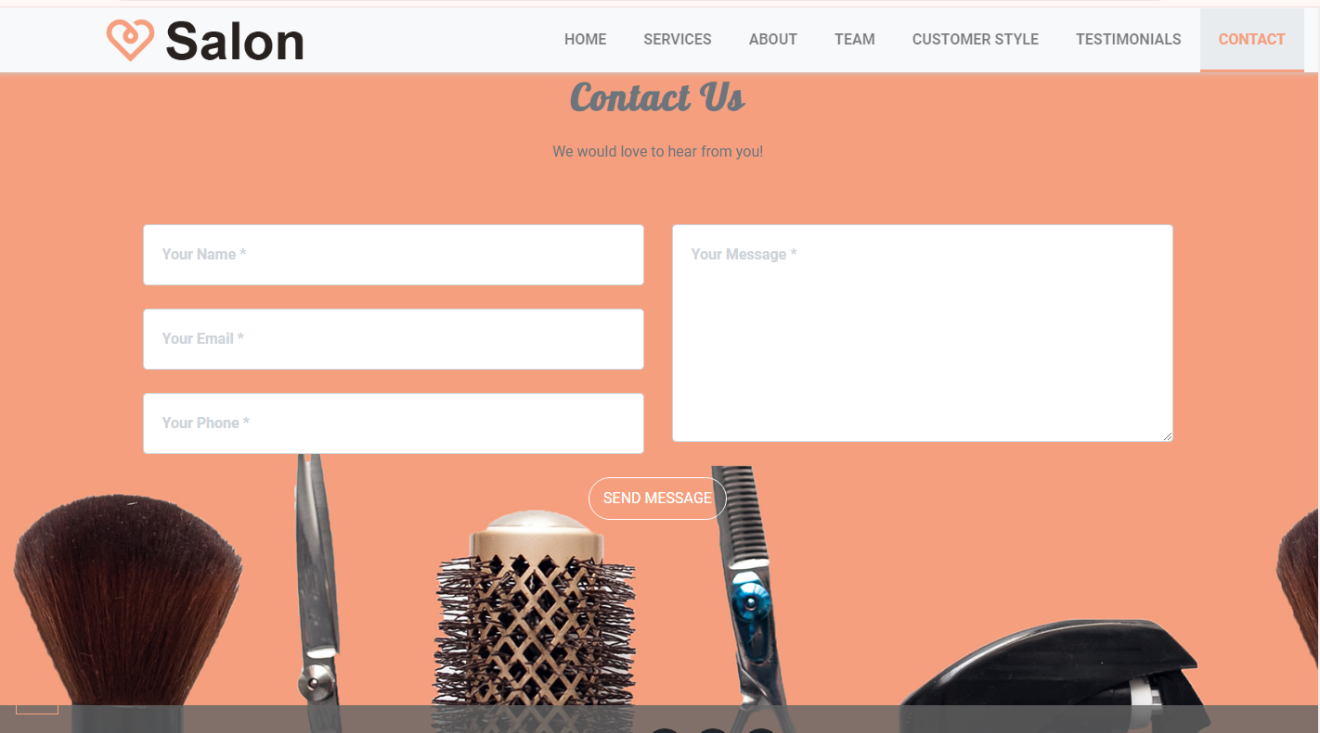

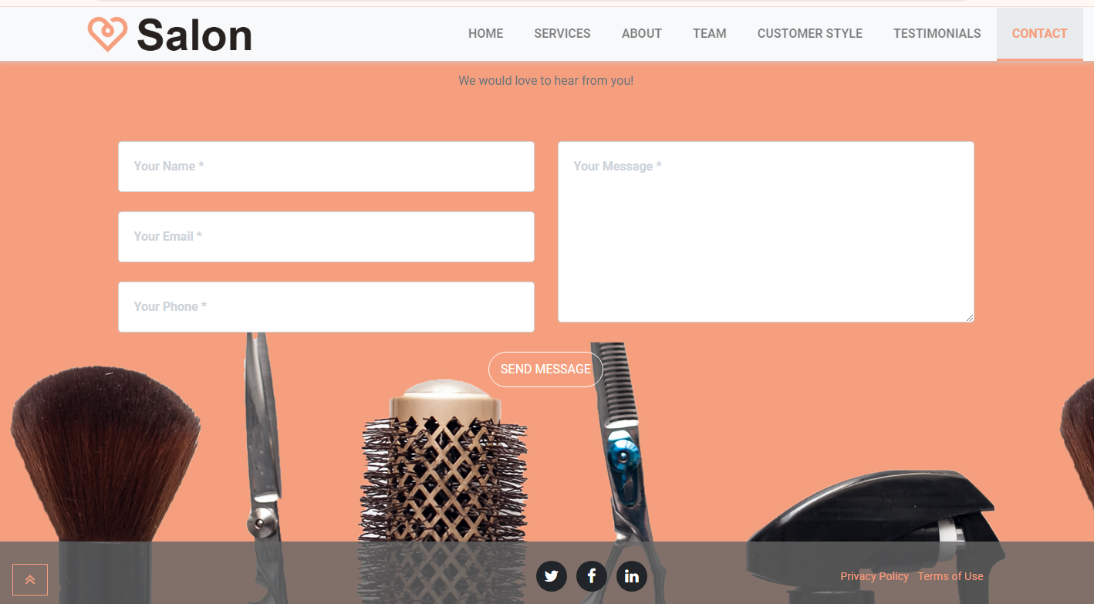

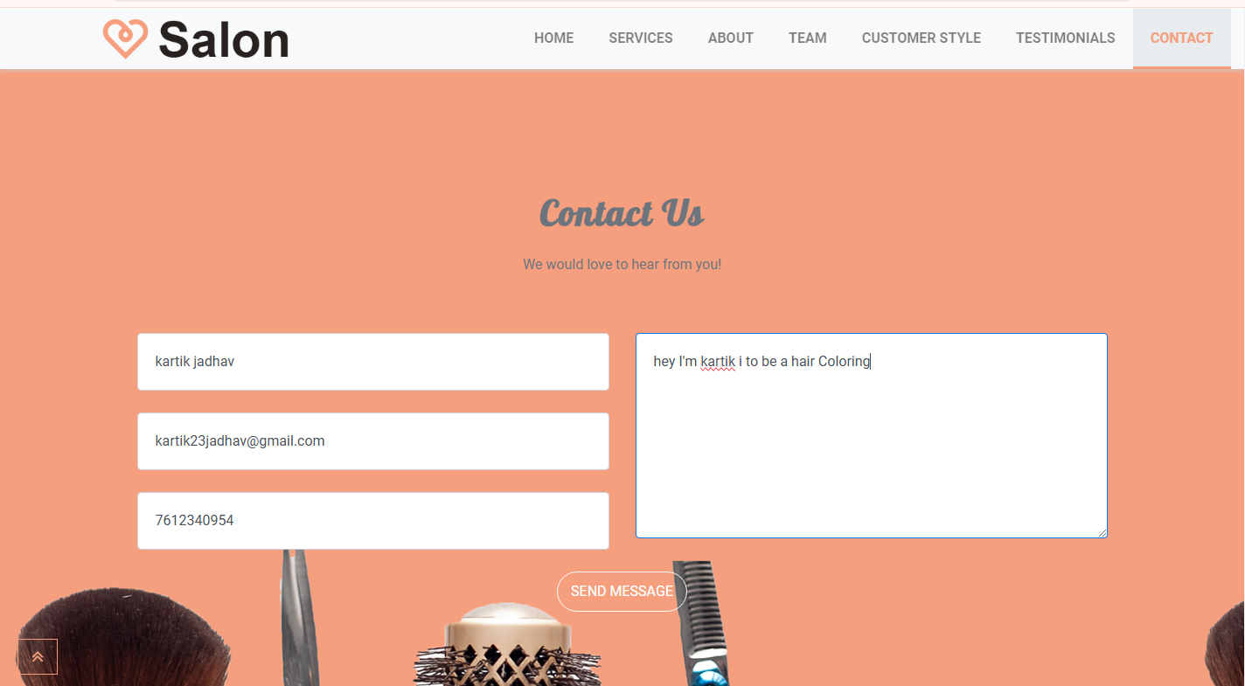

* Database :

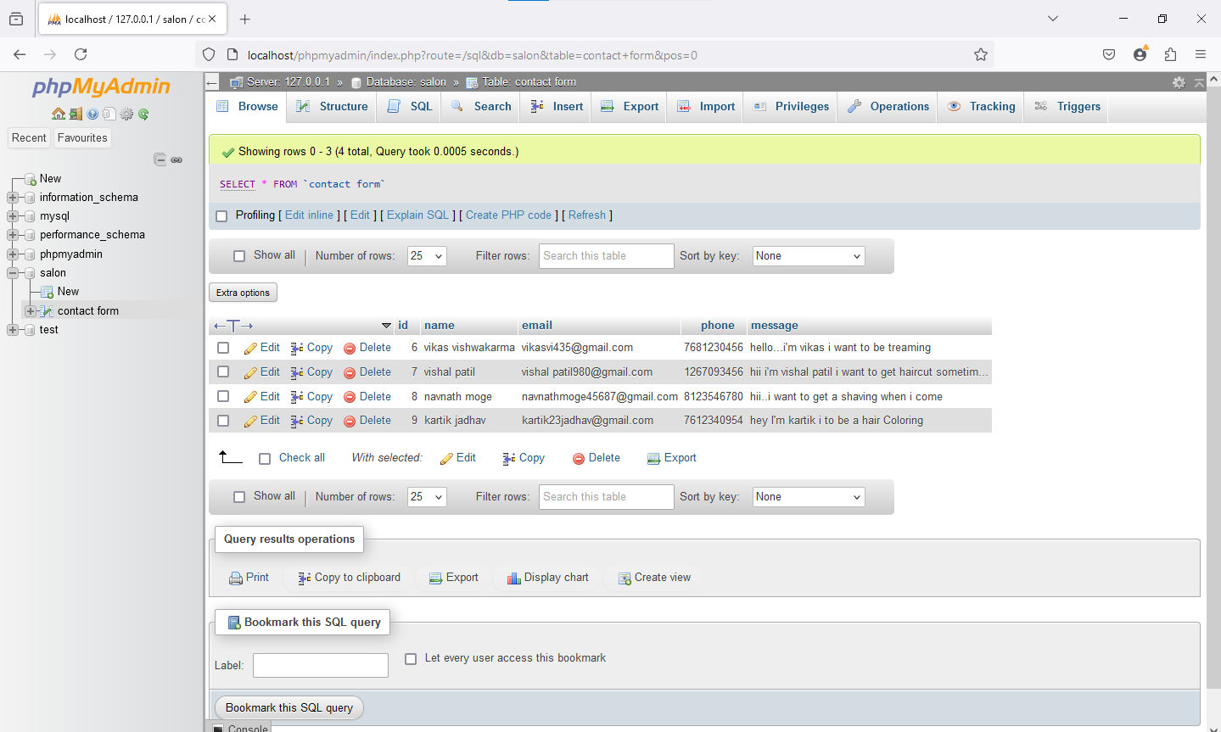

**4.2 Limitations :**

1. Limited services: Men's beauty salons may not offer as wide a range of services as women's salons.

2. Lack of privacy: Men may feel self-conscious about their appearance or prefer more privacy during services.

3. Higher prices: Men's beauty salons may charge more for services.

4. Limited availability: Men's beauty salons may have limited locations or hours.

5. Quality of services: Men's beauty salons may vary in quality.

6. Lack of personalized service: Men's beauty salons may not offer tailored advice or services.

7. Limited product selection: Men's beauty salons may only offer a limited range of products.

8. Time constraints: Men's beauty salons may have time limits for services.

9. Limited technology: Men's beauty salons may not have access to the latest technology.

10. Limited online presence: Men's beauty salons may not have a strong online presence.

men's beauty salons can work to address these issues and create a more welcoming and inclusive environment for their clients.

**4.3 Future Enhancement :**

1. Online booking and scheduling

2. Virtual consultations and personalized recommendations

3. Expanded service offerings (e.g. skincare, makeup, etc.)

4. Advanced technology integration (e.g. AR/VR try-on, AI-powered hair analysis)

5. Enhanced customer loyalty program

6. Increased focus on sustainability and eco-friendliness

7. Partnerships with influencers and brands

8. Educational resources and workshops for clients

9. Personalized product recommendations and sales

10. Integration with popular men's grooming apps

11. In-salon entertainment and relaxation options (e.g. VR headsets, etc.)

12. Expanded product offerings and retail space

13. Enhanced staff training and education

14. Improved customer data analysis and insights

15. Increased focus on inclusivity and diversity

16. Online community and forum for clients

17. Collaborations with other businesses and services

18. In-salon events and workshops

19. Personalized marketing and communication

20. Integration with wearable technology and health tracking devices.

a men's beauty salon can stay ahead of the competition, improve customer satisfaction, and expand its offerings to meet the evolving needs of its clients.

**BIBLIOGRAPHY**

**ANNEXURE : Sample Program Code**

<!**DOCTYPE html>**

**<html class="no-js" prefix="og: http://ogp.me/ns#" lang="en-IN">**

**<head>**

**<meta charset="utf-8">**

**<meta http-equiv="X-UA-Compatible" content="IE=edge,chrome=1">**

**<title>Beauty &amp; Salon</title>**

**<meta http-equiv="x-ua-compatible" content="ie=edge">**

**<meta name="viewport" content="width=device-width, initial-scale=1, shrink-to-fit=no">**

**<meta name="description" content="Salon We" />**

**<link href="img/beauty-salon_logo_96dp.png" rel="apple-touch-icon" sizes="96x96">**

**<link href="img/beauty-salon_logo_96dp.png" rel="icon" sizes="96x96" type="image/png">**

**<meta content="img/beauty-salon_logo_96dp.png" name="msapplication-TileImage">**

**<meta property="og:url" content="https://www.boostraptheme.com/demo/index.html" />**

**<meta property="og:title" content="Beauty and Salon" />**

**<meta property="og:locale" content="en_IN" />**

**<meta property="og:site_name" content="Boostraptheme" />**

**<meta name="twitter:card" content="summary" />**

**<meta name="twitter:site" content="BoostrapTheme" />**

**<meta name="twitter:creator" content="BoostrapTheme" />**

**<link href="https://fonts.googleapis.com/css?family=Lobster|Roboto:400,700" rel="stylesheet">**

**<link href="https://fonts.googleapis.com/css?family=Great+Vibes" rel="stylesheet">**

**<link rel='stylesheet' href="https://maxcdn.bootstrapcdn.com/font-awesome/4.7.0/css/font-awesome.min.css">**

**<link rel="stylesheet" href="css/owl.carousel.min.css">**

**<link rel="stylesheet" href="css/owl.theme.default.min.css">**

**<link rel="stylesheet" href="css/magnific-popup.css">**

**<link rel="stylesheet" href="css/animate.min.css">**

**<link rel="stylesheet" href="css/app.css">**

**<script src="js/jquery.min.js"></script>**

**<script>**

**$(window).on('load', function(){ $(".loader").fadeOut(2000); });**

**$(function () {**

**new WOW().init();**

**});**

**</script>**

**</head>**

**<body>**

**<div class="loader"></div>**

**<!-- NAVIGATION**

**=================-->**

**<nav class="navbar navbar-expand-lg navbar-light" id="mainNav" data-toggle="affix">**

**<div class="container-fluid">**

**<a class="navbar-brand js-scroll-trigger" href="index.html"><img src="img/logo.png" style="max-height: 60px;" alt="" class="img-fluid"></a>**

**<button class="navbar-toggler navbar-toggler-center ml-auto py-3 my-2 " type="button" data-toggle="collapse" data-target="#navbarResponsive" aria-controls="navbarResponsive" aria-expanded="false" aria-label="Toggle navigation">**

**Menu**

**<i class="fa fa-bars"></i>**

**</button>**

**<div class="collapse navbar-collapse" id="navbarResponsive">**

**<ul class="navbar-nav text-uppercase ml-auto">**

**<li class="nav-item">**

**<a class="nav-link js-scroll-trigger" href="#home">Home</a>**

**</li>**

**<li class="nav-item">**

**<a class="nav-link js-scroll-trigger" href="#services">Services</a>**

**</li>**

**<li class="nav-item">**

**<a class="nav-link js-scroll-trigger" href="#about">About</a>**

**</li>**

**<li class="nav-item">**

**<a class="nav-link js-scroll-trigger" href="#team">Team</a>**

**</li>**

**<li class="nav-item">**

**<a class="nav-link js-scroll-trigger" href="#portfolio">Customer style</a>**

**</li>**

**<li class="nav-item">**

**<a class="nav-link js-scroll-trigger" href="#testimonials">Testimonials</a>**

**</li>**

**<li class="nav-item">**

**<a class="nav-link js-scroll-trigger" href="#contact">Contact</a>**

**</li>**

**</ul>**

**</div>**

**</div>**

**</nav>**

**<!-- HEADER**

**=================-->**

**<header id="home">**

**<div id="carouselExampleIndicators" class="carousel slide" data-ride="carousel">**

**<ol class="carousel-indicators">**

**<li data-target="#carouselExampleIndicators" data-slide-to="0" class="active"></li>**

**<li data-target="#carouselExampleIndicators" data-slide-to="1"></li>**

**</ol>**

**<div class="carousel-inner" role="listbox">**

**<div class="carousel-item active" >**

**<div class="home-content-box">**

**<div class="home-content-box-inner text-center">**

**<div class="home-heading animated fadeInDown" >**

**<h3>Fascinating than any <br> fashion salon</h3>**

**</div>**

**<div class="home-btn wow fadeInUp" data-wow-delay="0.3s" >**

**<a class=" js-scroll-trigger" href="#contact" role="button" title="View Our Work"><button class="btn btn-lg btn-general btn-greenish ">Book Now</button></a>**

**</div>**

**</div>**

**</div>**

**</div>**

**<div class="carousel-item" >**

**<div class="home-content-box">**

**<div class="home-content-box-inner text-center">**

**<div class="home-heading animated fadeInDown" ><h3>your hair style <br> our passionate team </h3></div>**